Noach

This is the line
righteous
corrupt

end flesh

make yourself an ark this is how

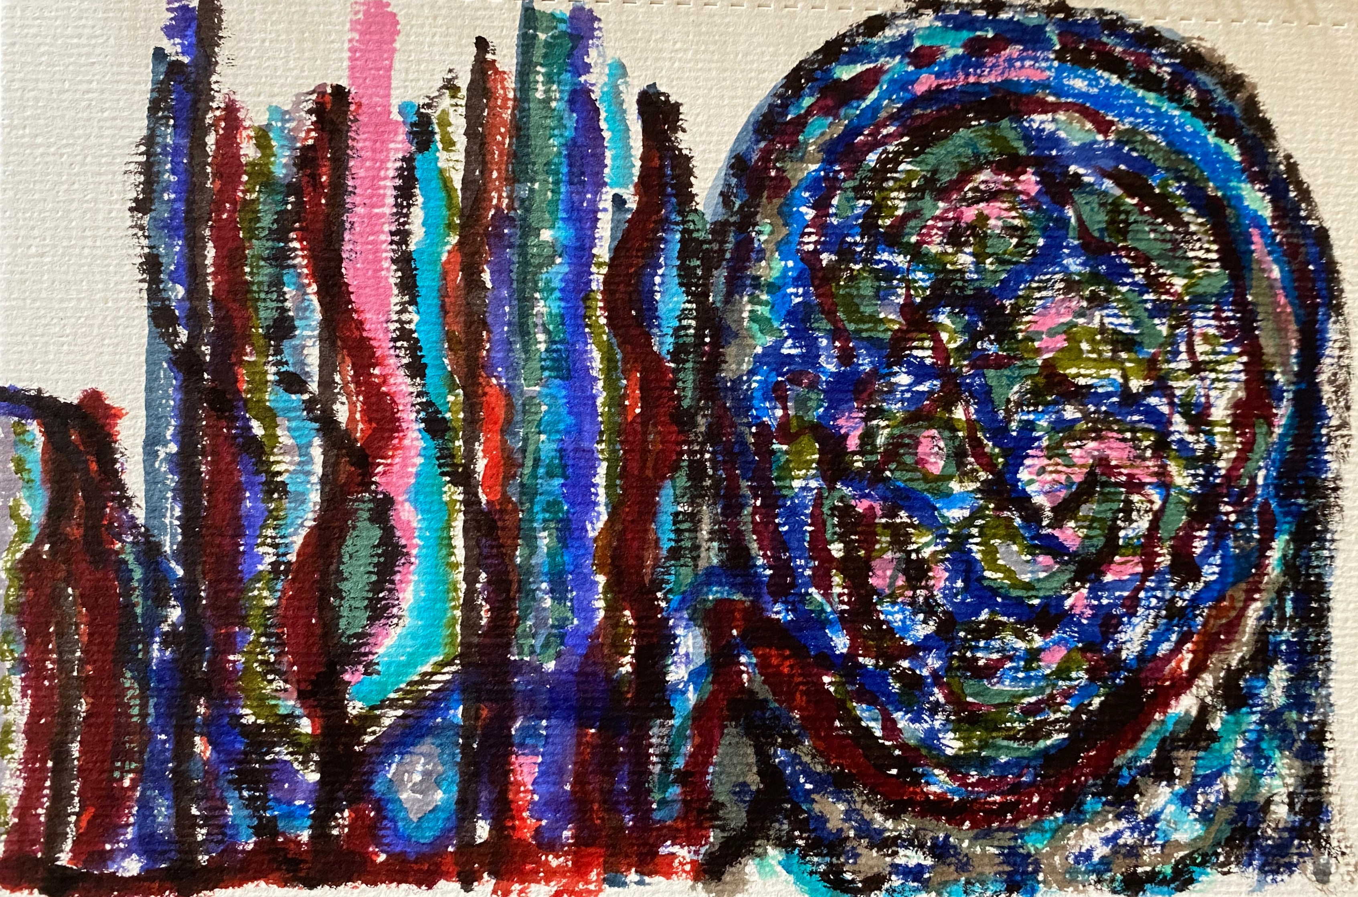

opening for daylight

My part

flood
waters upon
destroy all

establish
with you
and you shall

shall come to you to stay alive.

did so
just as
he did

