Wednesday, December 2, 2020 Vayishlach
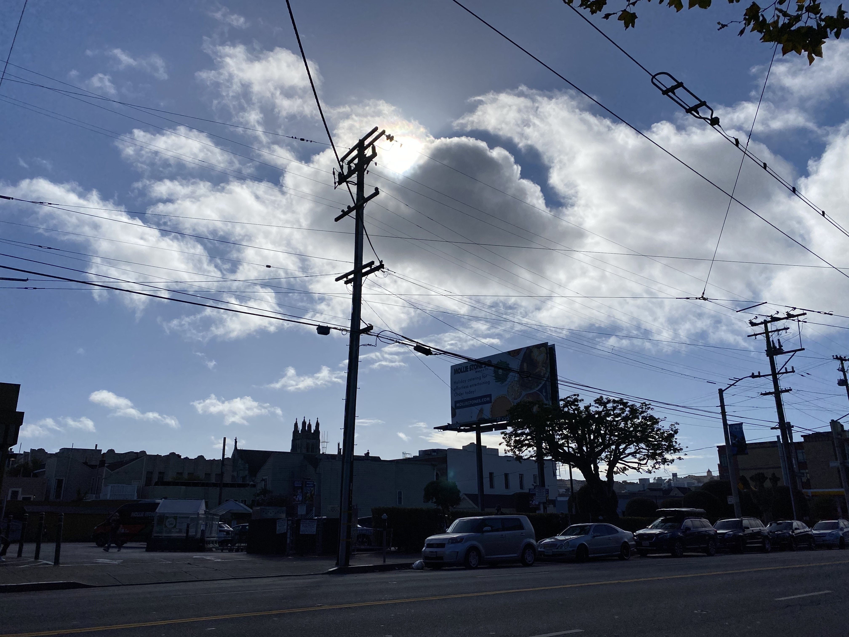
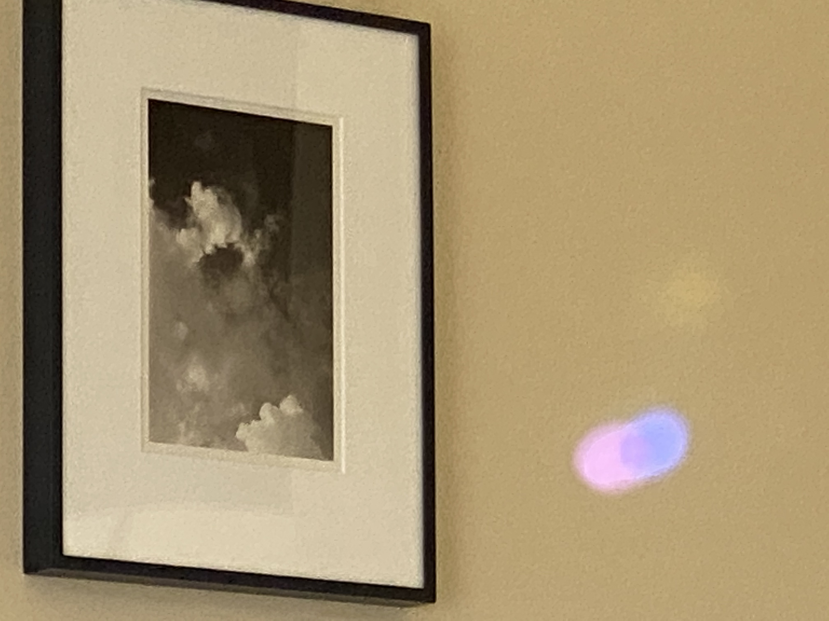
Jacob was left alone. And a man wrestled with him until the break of dawn.
When he saw that he had not prevailed against him, he wrenched Jacob’s hip at its socket, so that the socket of his hip was strained as he wrestled with him.
Then he said, “Let me go, for dawn is breaking.” But he answered, “I will not let you go, unless you bless me.”
Said the other, “What is your name?” He replied, “Jacob.”
Said he, “Your name shall no longer be Jacob, but Israel, for you have strivenwith beings divine and human, and have prevailed.”
Jacob asked, “Pray tell me your name.” But he said, “You must not ask my name!” And he took leave of him there.
So Jacob named the place Peniel, meaning, “I have seen a divine being face to face, yet my life has been preserved.”
The sun rose upon him as he passed Penuel, limping on his hip.
That is why the children of Israel to this day do not eat the thigh muscle that is on the socket of the hip, since Jacob’s hip socket was wrenched at the thigh muscle.

