Wednesday, November 11, 2020 Chayyai Sarah

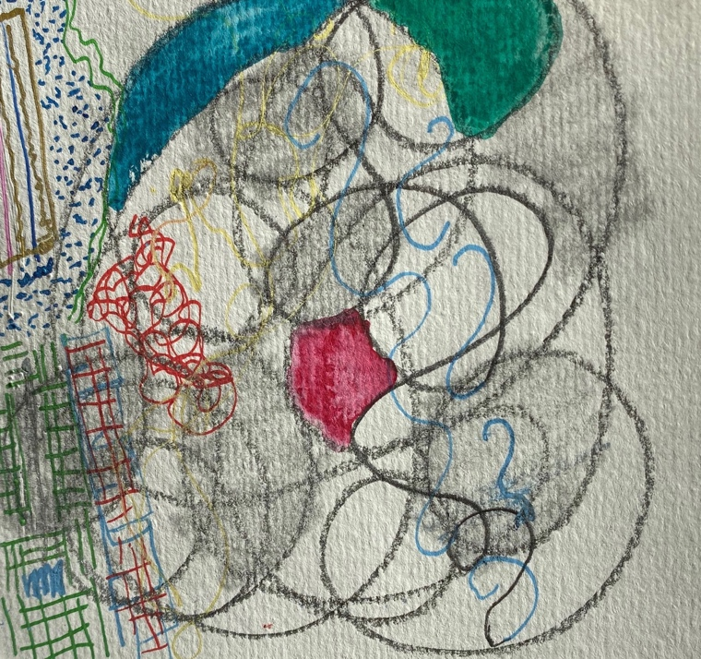

Sarah’s lifetime
The span of Sarah’s life

Sarah died
And Abraham proceeded to mourn
to bewail

Then Abraham rose and spoke
Then Abraham bowed low

*

I give you the field
I give you the cave
In the presence

Go and bury your dead.

Thus the field

*
Some words in the vocabulary of grief may include:
Abandoned Ache Adrift Aimless Anxiety Astonish Battered Bereave Broken Churning Crash Cruel Crying Death Denial Desolate Dimensionless Dirge Disaster Discordant Elegy Emptiness Endless Endure Eulogy Fear Fractious Grief Griefless Griefstricken Griefstruck Grotesque Hanging Heart Heartache Heartbreak Howl Inarticulate Isolate Jumpy Keening Knell Lamentation Lost Missing Moan Morose Mourn Oscillation Panic Remember Requiem Restless Sobbing Sorrow Strength Swept Tears Terror Timeless Torture Wail Waves Weakness Weep Wordless Wrench Wring Yearn Dorothy P. Holinger, The Anatomy of Grief

